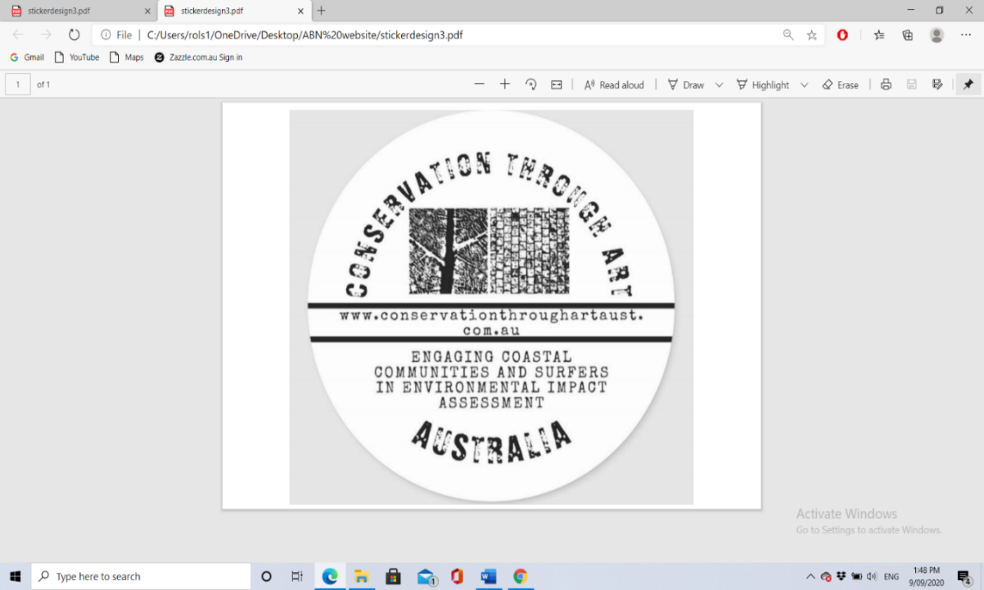

[www.conservationthroughartaust.com.au](http://www.conservationthroughartaust.com.au)

**A creative initiative by Roland Kopcsandy.**

**Initial contact and order form for Fine Art photographic prints and/or canvas prints (photos printed onto canvas).**

This is an editable pdf form. First read all the notes 1-8, then simply fill out the ‘’order details’’ section electronically (digitally) and email the completed form back to me at [info@conservationthroughartaust.com.au](mailto:info@conservationthroughartaust.com.au)

**Notes:**

1: All my work is completed by Mirage Photographic in Perth. The quotes for canvas prints are equivalent to the finished canvas (stretched, taped up and with a string ready to hang on the wall).

2: Once a completed order form is received by me, I will make initial contact with the potential buyer and arrange a deposit transaction (for items over $30). This can be done, by negotiation, in any way that is suitable/appropriate for both the buyer and me. ***This is not done through my online shop on my web site.***

3: For items over $30, an order will only be finalised and put into Mirage by me once a deposit is secured to me equivalent to %20 of the total purchase price of the item.

4: Once a work has been completed by Mirage, the buyer will have two weeks maximum to arrange a pick-up of the finished piece. Finished pieces cannot be stored indefinitely at Mirage or by me.

4: Completed work can be picked up from me directly (Armadale) or picked up at Mirage Photographics, with an agreed upon meeting time/date once the total purchase amount has been finalised.

5: **Please note, I do not have an eftpos machine and deposits/final purchase transactions are a personal transaction between me as the artist and you the buyer. This does not involve Mirage Photographics directly. Purchasing of fine art is not done through my online shop on my web site.**

6: Prices quoted here are for ***unframed*** work. Framing considerations are left to the buyer.

7: These are fine art works. I do not take orders for multiple/mass produced canvases or prints. I sell up to 3 copies of each image displayed online (as a limited-edition artwork), before the images are removed from my online display and replaced with new art works.

8: For all relevant tax/GST, receipt, and warranty information, please refer to the *business* page of my web site.

**Below: Cost of photographic prints on canvas.**

|  |  |
| --- | --- |
| **Size (cm)** | **Purchase price (please note that approx.’ 2/3 of this price is the cost to me to produce the canvas print).** |
| 30cm x 45cm | $100 |
| 40cm x 60cm | $150 |
| 50cm x 75cm | $170 |
| 60cm x 80cm | $200 |
| 75cm x 100cm | $300 |
| 80cm x 120cm | $320 |

**Below: Cost of photographic prints on Satin finish photographic stock** (Ilford Galerie Smooth Pearl 310GSM paper) – unframed. Metallic paper is another well suited surface for landscape photography however it’s only economical for large format prints above 8x12”. Prices are the same as quoted for Satin).

|  |  |
| --- | --- |
| **Size (inches)** | **Purchase price.** |
| 6 x 9 | $20 |
| 8 x 12 | $40 |
| 12 x 18 | $60 |
| 16 x 24 | $80 |
| 20 x 32 | $120 |

**Order details (to be filled out by you the buyer).**

|  |  |
| --- | --- |
| Your name |  |
| Your home address |  |
| Your email address |  |
| Your preferred contact number |  |
| Specifics of your order (please specify whether you want a photographic print or a print on canvas and the title of the image – as taken from my fine art gallery on the web site) |  |
| Size of artwork (choose from sizes in tables on this form) |  |
| Today’s date (order date) |  |
| Agreed deposit amount if applicable (%20 of total purchase price) |  |

***Thank you for your support. It is both needed and appreciated.***

