

**LESSON PLAN for private tutoring. ER 1.**

**OVER-ARCHING UNIT OF LEARNING (UNIVERSITY BASED): ENVIRONMENTAL RESTORATION.**

**CENTRAL CONCEPTS: ECOLOGICAL SUCCESSION AND ECOLOGICAL DISTURBANCE.**

**SPECIFIC CONCEPTUAL LEARNING: DIFFERENTIATING BETWEEN PRIMARY AND SECONDARY SUCCESSION, UNDERSTANDING ECOLOGICAL DISTURBANCE.**

**YEAR GROUP/LEVEL: YEAR 10-11.**

**MATERIALS/RESOURCES: WORKSHEET ‘ER 1’, MOBILE PHONE WITH CAMERA FUNCTION OR DIGITAL CAMERA, ACCESS TO LOCAL NATURAL AREAS (BUSHLAND, NATURE RESERVES, NATIONAL PARKS, CONSERVATION PARKS ETC)**

**SPECIFIC LEARNING OUTCOMES:** At the end of this activity students will be able to:

1: Explain what ecological succession is and differentiate between primary and secondary succession.

2: Recognize and provide examples of each of the above using pictures from books/magazines etc. (in the case of primary succession) and using their own photographic documentation from their local natural environment in the case of secondary succession (and primary succession if possible).

3: Explain the concept of ecological disturbance and show understanding of the idea through written explanation and real-life recognition of ‘disturbance sites’ using photographic documentation.

4: Recognize and document sites of primary succession (if possible), secondary succession and disturbance from their own local natural environment.

5: Discuss their images/an image of a natural site in terms of these concepts and provide reasoning/rationality for their observations and ideas.

6: articulate the relationships between disturbance and succession in generalized terms.

**ACTIVITY ONE.**

Write down what you think the term *succession* means in relation to the natural environment. Do not refer to any textbooks or other sources of information such as the internet.

Write down what you think the term *disturbance* means in relation to the natural environment. Do not refer to any textbooks or other sources of information such as the internet.

**ACTIVITY TWO.**

Study the two images below and write a paragraph on each explaining what you think the picture exemplifies in terms of how a site in the natural environment changes over time. Consider (in terms of biological and ecological processes):

* what may have happened to stimulate the changes (in the past);
* what may happen in the future;
* what may influence or determine how this natural site will develop over time;
* how long the changes will take and what may influence or determine that time frame;
* whether the developing/new site will mimic the natural characteristics of the site before the change, and what you think might affect the way this happens (or doesn’t happen);
* what kinds of things might affect what plants and animals appear at the site after the change;
* how and why these plants and animals appear there and;
* that the image you see captures only a static moment in time; all natural sites change across time.

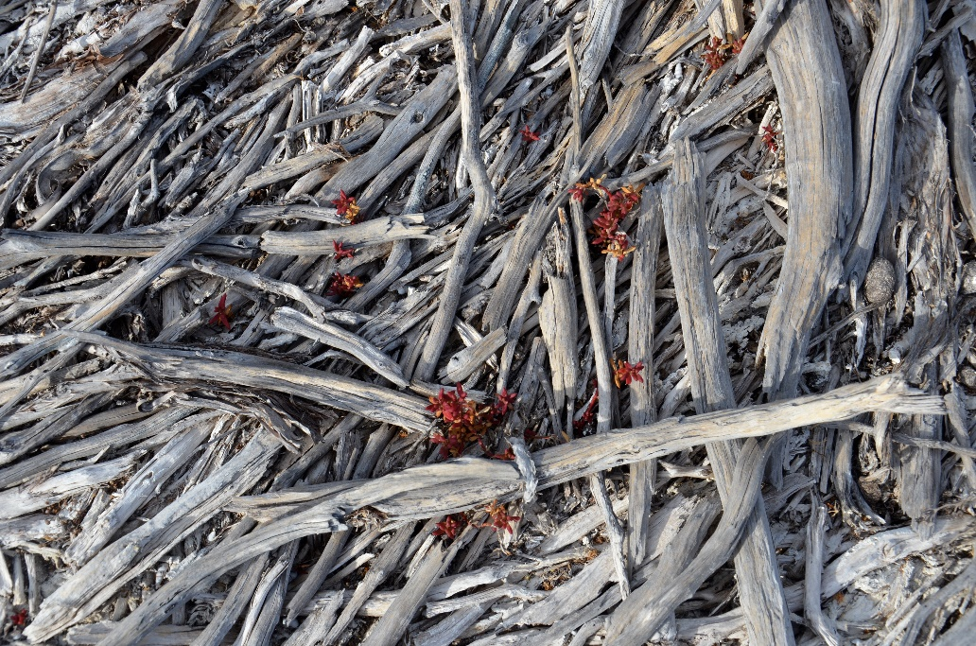

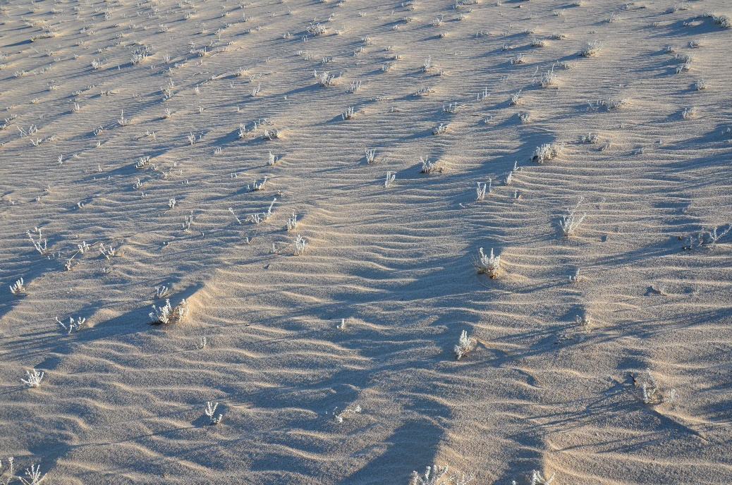

**ACTIVITY THREE.**

Provide a definition for *ecological succession* and differentiate between primary succession and secondary succession within that definition, using examples for each type of succession.

Provide a definition for *ecological disturbance.*

Describe how the two are inter-related.

(Your tutor will help with this).

**ACTIVITY FOUR.**

Some ecosystems are maintained by disturbance. For example, the biodiversity in many bush areas of Australia is maintained through periodic burning, with the plants being adapted to a historical regime of regular burning occasioned and mediated by lightning strikes and burning by Indigenous Aboriginals.

With this in mind, consider the following hypothetical scenario:

A serial arsonist in South West W.A. is allowed to light fires at will over a 4-year time frame before he is finally identified and criminalized by police. As a result, one part of a National Park is subject to 3 burns within an 18-month period and each time the bush is burnt, it had just begun to regenerate in a healthy way. The site now, however, is beginning to show signs of an increased diversity of plants but not all of them are native to the area. Some are weeds while others are simply species that would not normally appear there.

Discuss the above scenario in terms of disturbance and succession and in terms of both positive and negative biological/ecological perspectives.

**AT HOME/TAKE HOME ACTIVITY.**

Find a natural area in your locality (that you have access to without problems) that exemplifies a type of succession and complete the following:

* document it with at least 5 photos (refer to point 3 below);
* describe whether its an example of primary or secondary succession and provide reasoning and photos from the site to support your ideas;
* speculate as to what you think the disturbance was and how long ago it occurred, provide reasoning for this speculation;
* speculate what stage of succession the site is displaying (very early succession, very late succession etc.), provide reasoning for your ideas;
* Attempt to predict what the site will develop into over the next month, year, 5 years and ten years. Within this prediction, discuss the disturbance potential (likelihood of it reoccurring) and how this potential affects your prediction for the site’s future in terms of succession.